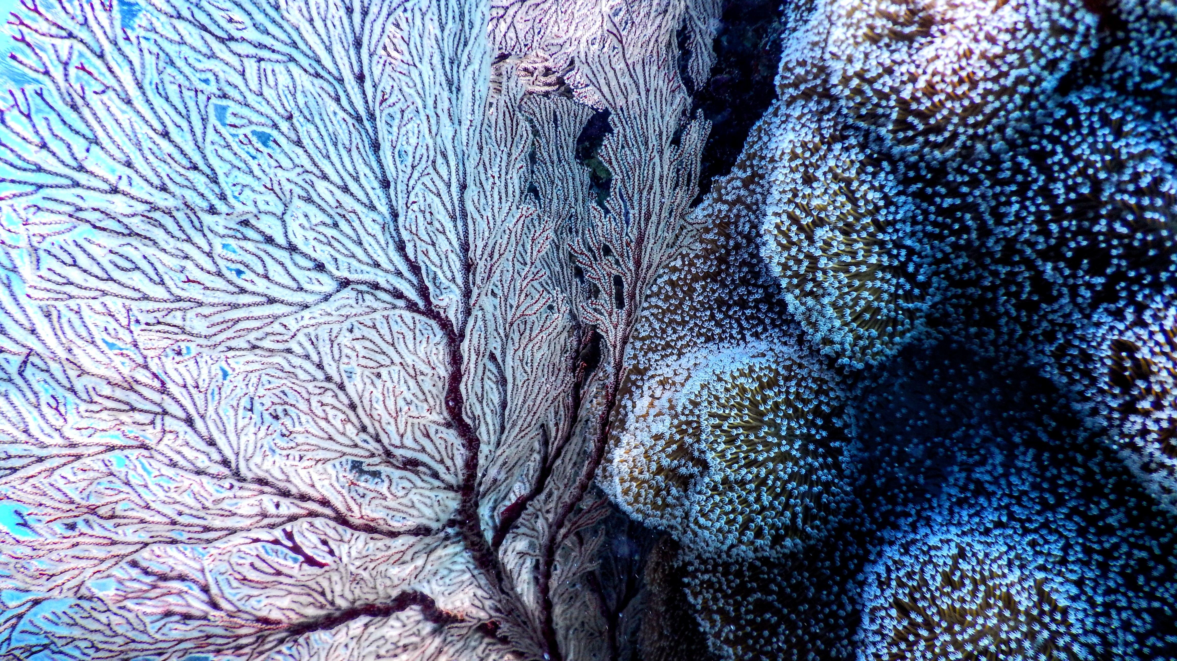



Concrete Materials



Image: Photo by Tomoe Steineck on Unsplash



Coral Reef

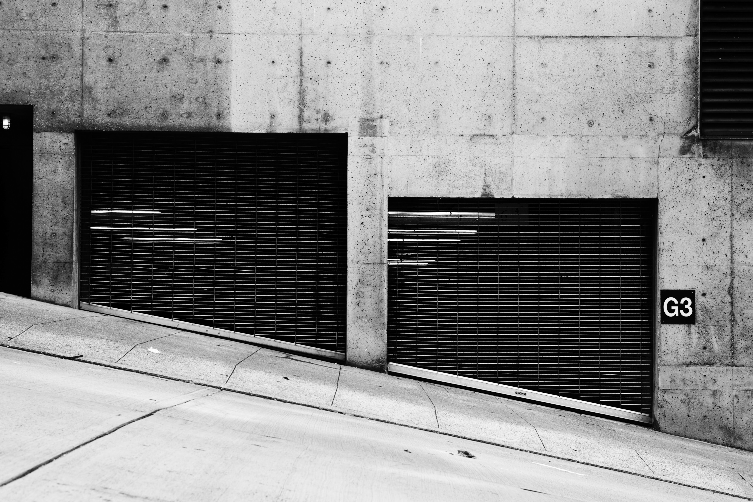

Image: Photo by Carl Nenzen Loven on Unsplash

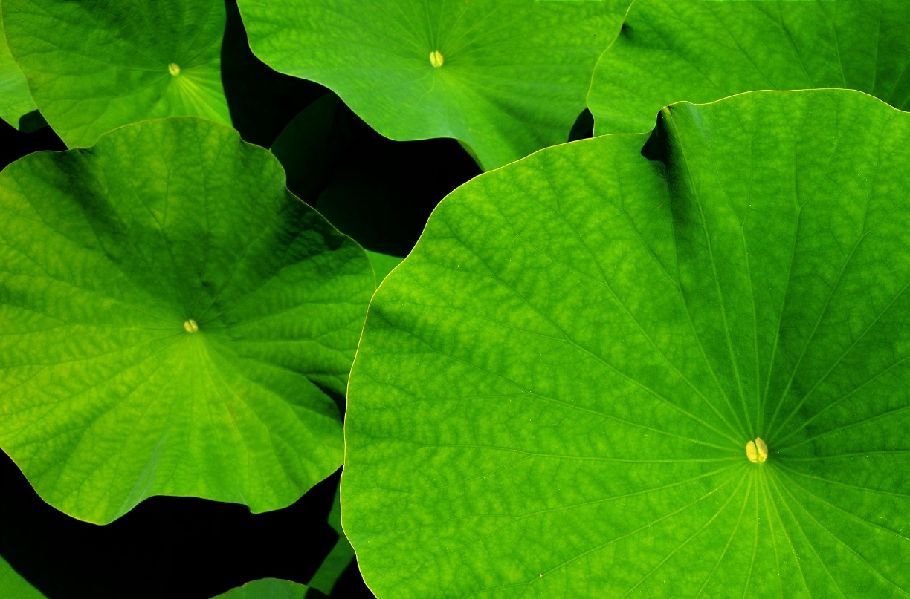



Image by [PIRO4D](https://pixabay.com/users/PIRO4D-2707530/?utm_source=link-attribution&utm_medium=referral&utm_campaign=image&utm_content=1556769) from [Pixabay](https://pixabay.com/?utm_source=link-attribution&utm_medium=referral&utm_campaign=image&utm_content=1556769)



Image by [ArtTower](https://pixabay.com/users/ArtTower-5337/?utm_source=link-attribution&utm_medium=referral&utm_campaign=image&utm_content=224020) from [Pixabay](https://pixabay.com/?utm_source=link-attribution&utm_medium=referral&utm_campaign=image&utm_content=224020)

Dam Water Intakes



Lotus Leaf

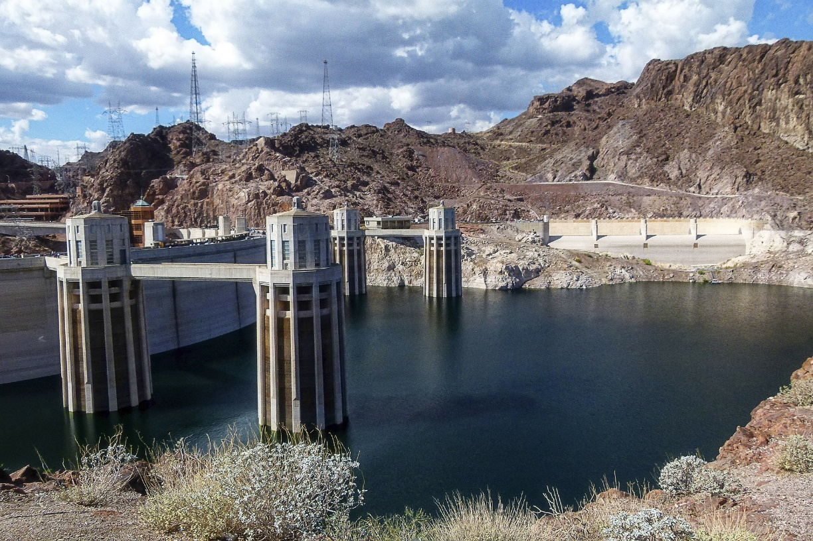

Unlike the current way we make concrete which produces CO2, Coral reefs sequester carbon into their structure. Blue Planet LLC is taking CO2 and seawater and precipitating out carbonate rocks which can be used in place of natural limestone rock (mined from quarries) which is a principal component of concrete.

Invasive quagga mussels are interfering with water systems such as the water intakes at the Hoover Dam. By mimicking the lotus leaf structure and its ability to store lubricants, researchers at the Pacific Northwest National Lab are developing a safer bioinspired coating called a Superhydrophobic Lubricant Infused Composite (SLIC). The coating has a similar surface structure to the lotus leaf and then the lubricant layer provides a frictionless surface.

(more info- <https://www.pnnl.gov/sites/default/files/media/file/SLIC%20Foul-Release%20Coating%20Flyer_v7_opt.pdf>)